i) Write a shell script to calculate the area and perimeter of a rectangle when the length and breadth are given as input.

Code:

echo "input number1"
read n1
echo "input number2"
read n2
ar=$(($n1*$n2))
echo "area is" $ar
pr=$((2*($n1+$n2)))
echo "perimeter is" $ar

output:

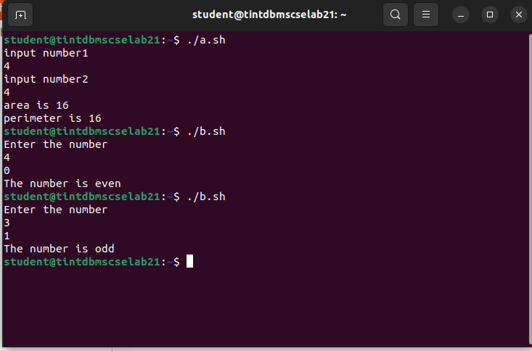
ii) Write a shell script to check if the given integer is EVEN or ODD.

Code:

echo "Enter the number"
read number
rem=$((number%2))
echo $rem
if [ $rem -eq 0 ]
then
echo "The number is even"
else
echo "The number is odd"
fi

output:

iii) Write a shell script to find the largest integer among three given integers.

Code:

echo "input n1"
read n1
echo "input n2"
read n2
echo "input n3"
read n3
if [ $n1 -gt $n2 ] && [ $n1 -gt $n3 ]
then
echo "n1 is greater than n2 and n3"
elif [ $n2 -gt $n1 ] && [ $n2 -gt $n3 ]
then
echo "n2 is greater than n1 and n3"
else [ $n3 -gt $n1 ] && [ $n3 -gt $n2 ]
echo "n3 is greater than n1 and n2"
fi

output:

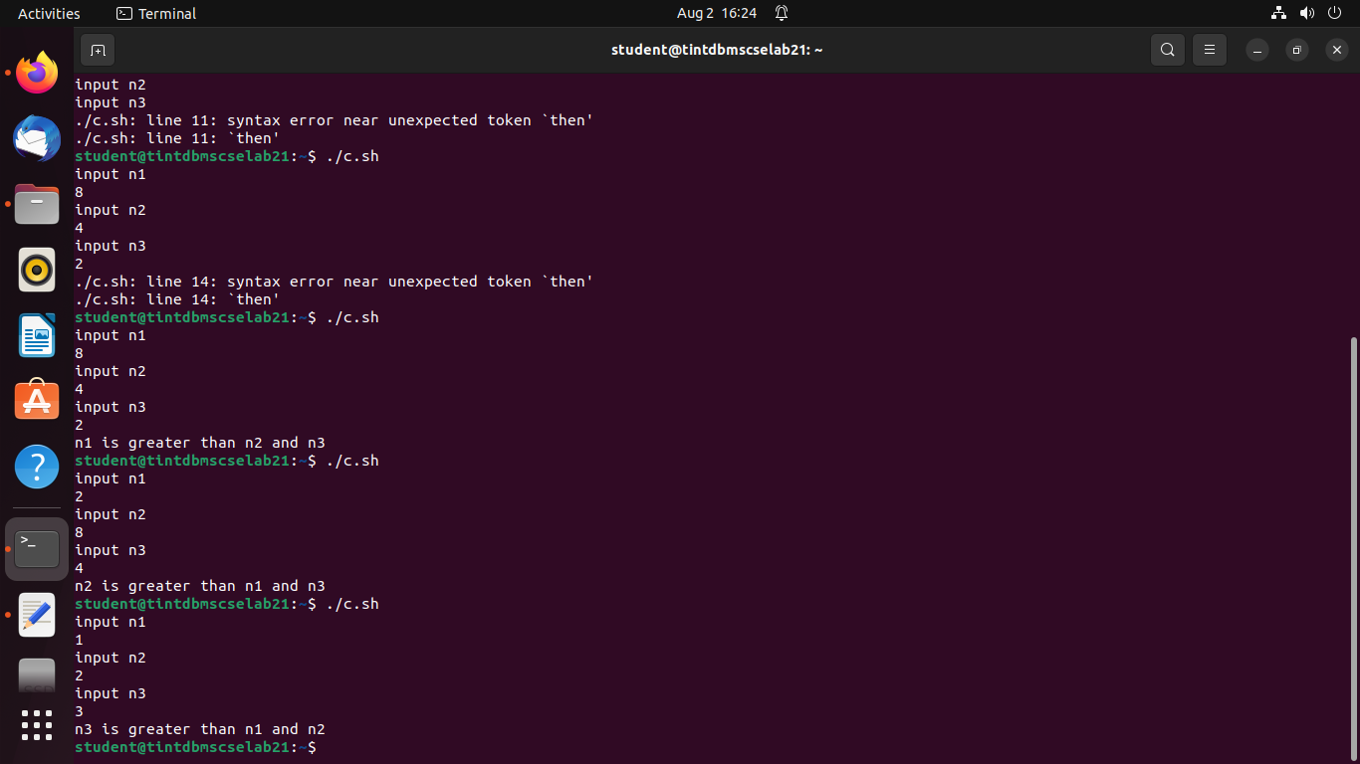
iv) Prime number or Not

code :

echo "Enter Number"
read n
for((i=2; i<=$n/2; i++))
do
ans=$(( n%i ))
if [ $ans -eq 0 ]
then
echo "$n is not a prime number."
exit 0
fi
done
echo "$n is a prime number."

output:

